Day 1
- Introduction to AI, ML, Data Science
- Industry Applications
- Setting up Python Environment

Day 1: Introduction to AI, Machine Learning, Data Science & Environment Setup

Learning Objectives
By the end of Day 1, students will be able to:
- Understand Artificial Intelligence (AI)
- Understand Machine Learning (ML)
- Understand Data Science (DS)
- Know the differences between AI, ML, and DS
- Explore real-world applications
- Set up Python and Jupyter Notebook environment

1. What is Artificial Intelligence (AI)?
Artificial Intelligence is the ability of machines to perform tasks that normally require human intelligence.

Examples
- ChatGPT answering questions
- Self-driving cars
- Face recognition
- Voice assistants (Siri, Alexa, Google Assistant)
- Recommendation systems

Simple Diagram
Artificial Intelligence (AI)
│
├── Machine Learning
│ ├── Supervised Learning
│ ├── Unsupervised Learning
│ └── Reinforcement Learning
│
└── Deep Learning

Real-Life Example
Suppose you upload a photo to Facebook.
AI can:
- Detect faces
- Identify objects
- Suggest tagging friends

2. What is Machine Learning (ML)?
Machine Learning is a subset of AI that enables computers to learn from data without being explicitly programmed.

Traditional Programming
Data + Rules → Output
Example:
if marks > 40:
print("Pass")
else:
print("Fail")
Rules are manually written.

Machine Learning
Data + Output → Model (Learns Rules)
Example:
A model learns house prices from previous sales data.
Area (sq ft) | Price
1000 | 20 lakh
1200 | 25 lakh
1500 | 30 lakh
The model learns the relationship and predicts prices for new houses.

3. What is Data Science?
Data Science is the process of extracting useful insights from data.

Data Science Process
Data Collection
↓
Data Cleaning
↓
Data Analysis
↓
Visualization
↓
Machine Learning
↓
Decision Making

Example
Amazon collects customer data:
- Purchased items
- Search history
- Ratings
Using Data Science, Amazon can:
- Recommend products
- Predict sales
- Improve customer experience

Difference Between AI, ML and Data Science
AI | ML | Data Science
Makes machines intelligent | Learns patterns from data | Extracts insights from data
Broad field | Subset of AI | Uses ML and statistics
Example: Chatbot | House Price Prediction | Sales Analysis

Relationship Diagram
Artificial Intelligence
│
└── Machine Learning
│
└── Deep Learning
Data Science
│
├── Statistics
├── Machine Learning
└── Data Visualization

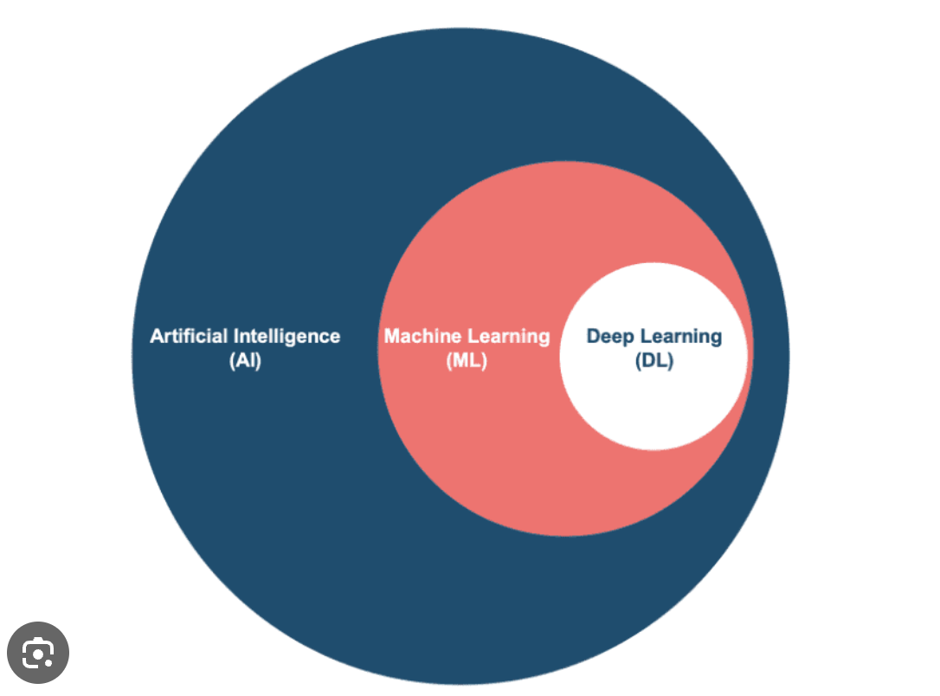

4. Industry Applications

Healthcare
- Disease prediction
- Medical image analysis
Example:
AI detects cancer from X-rays.

Banking
- Fraud detection
- Credit scoring
Example:
Detect suspicious transactions.

E-Commerce
- Product recommendations
- Customer segmentation
Example:
Amazon suggesting products.

Education
- Personalized learning
- Automated grading
Example:
AI-based learning platforms.

Transportation
- Self-driving cars
- Traffic prediction
Example:
Google Maps estimating travel time.

Social Media
- Face recognition
- Content recommendation
Example:
Instagram Reels recommendations.

5. AI vs ML Example
Imagine teaching a child to identify cats.

Traditional Programming
Write Rules:
- Has 4 legs
- Has tail
- Has whiskers
Difficult to cover every case.

Machine Learning
Provide thousands of cat images.
Cat Images
↓
Model Training
↓
Learns Patterns
↓
Predicts New Images
The machine learns automatically.

6. Environment Setup

Step 1: Install Python
Download Python from:
Python Official Website
Verify installation:
python --version
Output:
Python 3.x.x

Step 2: Install VS Code
Download:
Visual Studio Code
Extensions:
- Python
- Jupyter

Step 3: Install Jupyter Notebook
Open terminal:
pip install notebook
Run:
jupyter notebook
Browser opens automatically.

Step 4: Install Important Libraries
pip install numpy
pip install pandas
pip install matplotlib
pip install seaborn
pip install scikit-learn

First Python Program
print("Hello AI/ML World")
Output:
Hello AI/ML World

Practical Activity (Day 1)

Student Information Program
name = input("Enter Name: ")
age = int(input("Enter Age: "))
print("Student Name:", name)
print("Student Age:", age)

Sample Output
Enter Name: Akhil
Enter Age: 22
Student Name: Akhil
Student Age: 22

Day 1 Assignment

Theory Questions
- What is Artificial Intelligence?
- What is Machine Learning?
- What is Data Science?
- Differentiate AI and ML.
- List 5 applications of AI.

Practical Tasks
- Install Python.
- Install VS Code.
- Install Jupyter Notebook.
- Create a GitHub account.
- Write and execute:
  - Hello World Program
  - Student Information Program

Expected Outcome of Day 1
Students should be able to:
Explain AI, ML, and Data Science
Understand real-world applications
Install Python and required tools
Run Python programs successfully
Create a GitHub account for future project work
This is typically a 2–3 hour session with around 1.5 hours theory and 1 hour hands-on practice.

